Porter’s Five Force Analysis of Delta Airlines
Student’s Name
Institutional Affiliations

Porter’s Five Force Analysis of Delta Airlines
Introduction
Delta airlines and the aviation industry, in general, has experienced significant growth over the years. This has been largely attributed to the demand for transportation across several countries and the industrialization that has taken place. Most of the people seek to invest in other countries and thus need a mode of transport that will make their locomotion easy and fast. This has seen the industry rake in billions as they strive to provide quality service to its customers. The aviation industry is affected by several factors including fuel prices which determine to a great extent the prices that are charged for the airlines. These economic factors have impacted the industry in different ways. In order to gain a better understanding of the industry and the factors that affect it, porter five forces analysis comes in handy. The analysis provides details about rivalry, supplier power, barriers to entry, buyer power and the threat of substitutes. Therefore, this paper is a Porter’s five forces analysis of Delta Airlines
Porter’s Five Forces Analysis Chart of Delta Airlines
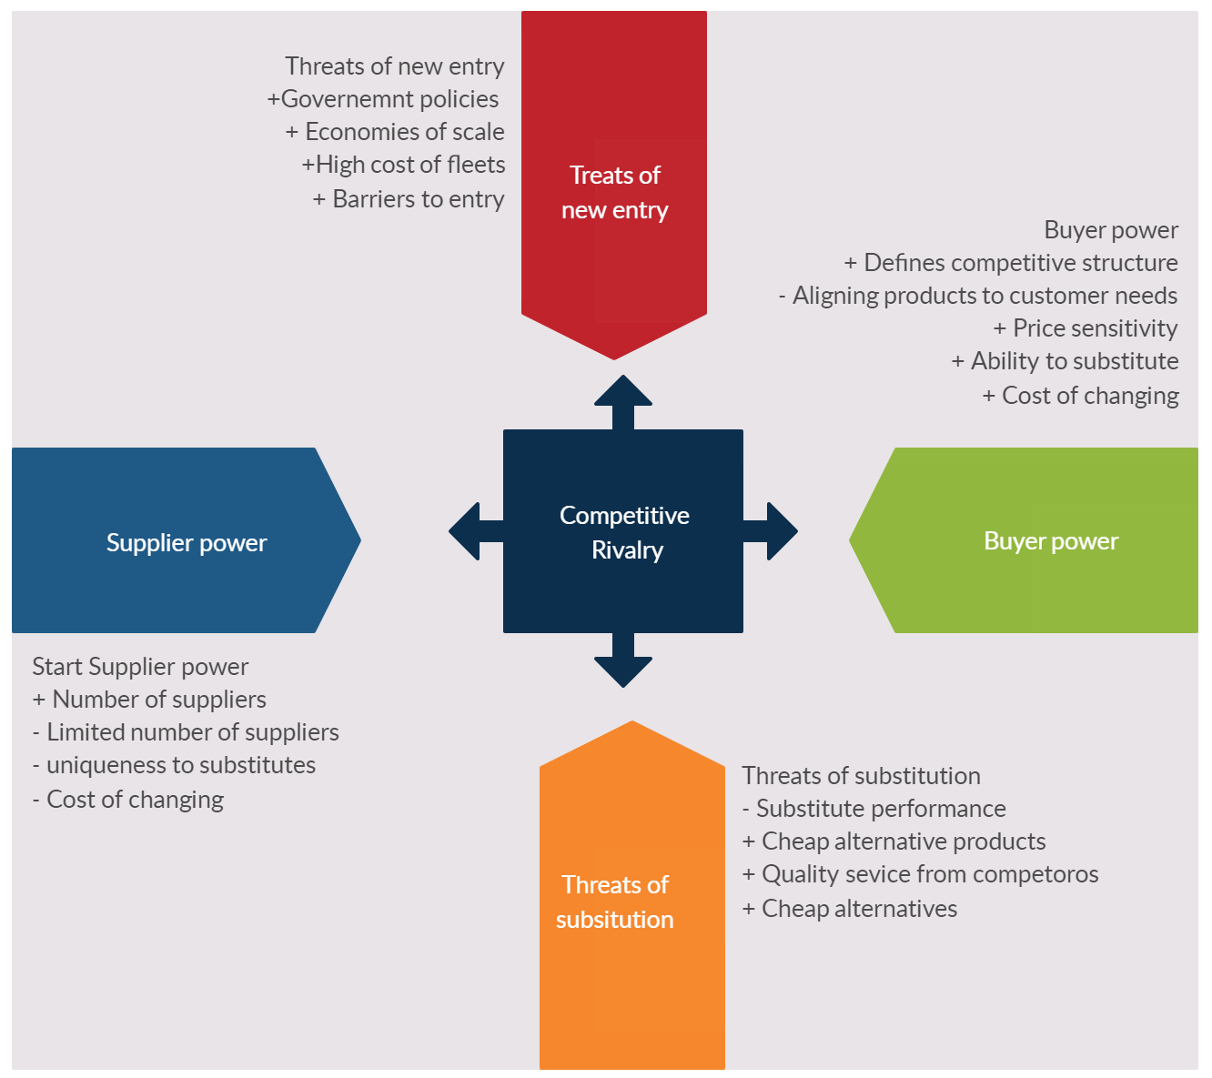

Barriers to New Entry
Barriers to entry refers to the factors that prevent some of the organization to venture into the airline industry (Baburaj & Narayanan, 2016). One such barrier to entry is the lack of finances to purchase a fleet of airlines. The cost incurred in purchasing airlines is relatively high and this forces most of the people with intentions of joining the industry to abandon their plans. The technology used in manufacturing the airlines contributes to the high prices and thus hinder the entry of many players. There is also the issue of competition in the industry. The industry has several players that have established themselves over the years such as delta airlines. They have built their own brand and thus customers prefer to book their planes. They provide high competition that makes it impossible for other players to come in and take up a sizeable share of the market. The liberalization of the industry also hinders players from joining the industry.
Rivalry
The aviation industry has experienced rivalry over recent years. This is due to organizations trying to provide quality service to the customers. They have increased the routes that they are operating and thus convenience customers to a great extent. Delta airlines being one of the major players has established numerous networks that ensure they cover most of the routes (McKenna, E. 2018). This locks out other players due to the preference of the customer to board them despite the presence of the other companies. Delta Airlines holds the largest market share in the US with its closest rivals being the American Airlines Group (Baxter, 2019). This goes to show the extent of rivalry present. The rivalry has also been brought about by the different products offered by airlines. Airlines strive to satisfy their customers and thus come up with lucrative products. This is intended to lure customers and thus promote the issue of rivalry in the aviation sector. The issue of creating brands also create a lot of rivalry within airlines as each seek to establish a brand that customers are able to identify with. Delta airlines have introduced numerous packages that have enabled them to fend off competition from its rivals.
Supplier Power
This relates to the pressure that suppliers put on the businesses such as raising prices or reducing the availability of their products (Arshed & Pancholi, 2016). This is an intentional action that seeks to enhance the growth of the airlines and increase the revenues achieved. Delta Airlines thrives in offering quality services which come at a cost. The packages offered entails numerous benefits for the customers which in turn they have to pay for it. Raising prices of such packages causes a disturbance in the airline sector as other airlines have to react in order to catch up with the market leader. The customer brand created allows it to change its prices with a bit of incentives and still manage to maintain its customers.
Buyer Power
This refers to the pressure that buyers can have on businesses to get them to provide higher quality products and better customer service (Baburaj & Narayanan, 2016). Buyers determine the choice of the airline that they use and thus have a strong buying power in them. The airlines in operation have to conform to what the consumers need for them to get revenues. Airlines such as Delta have been forced to align most of their products on the needs of the customers. This is to ensure that they get frequent customer all through the year. The demands and pressure exerted by buyers has led to the customer greeting the best form of service from the airline and other airlines in the aviation sector. The buyer power also shapes the competitive structure of the industry. Most of the airlines will compete to create products that meet the customer standards and thus enhance competition in the industry.
Threat of Substitutes
The threat of substitute is the availability of products that consumers could purchase outside of the industry (Baburaj & Narayanan, 2016). This means that consumers have an option of acquiring a product from outside the airline industry, and thus, pose a threat to the products found in the industry. This can result due to the competitors’ products being cheaper than what is offered in the industry. Another reason is that the cost involved by consumers in switching to the product is relatively low. This will make them decide to change products even though they might incur a little cost. Delta Airlines always ensures that they monitor the happenings of other sectors so as to check whether consumers may be attracted by similar products outside the industry (Baxter, 2019). This strategy has helped them to become market leaders as they research and get ahead of other competitors.
Conclusion
Delta Airlines is faced by numerous competitive forces in its quest to maintain its grip on the aviation market. One such force is that of new entrants. Although delta has established itself, new entrants may bring a lot of competition and thus affect their profit levels. Another competitive force is that of rivalry among industry players (McKenna, E. 2018). The airline industry has generated a lot of rivalry and this is bound to affect the strategies put in place by delta. They need to up their game if they wish to retain their shares. Bargaining power of buyers also enhances competition, and thus, it is important for the company to understand the customer’s needs and satisfy them.

References
Arshed, N., & Pancholi, J. (2016). 9 Porter’s Five Forces. Enterprise and its Business Environment.
Baburaj, Y., & Narayanan, V. K. (2016). Five Forces Framework.
Baxter, G. (2019). Capturing and Delivering Value in the Trans-Atlantic Air Travel Market: The Case of the Air France-KLM, Delta Air Lines, and Virgin Atlantic Airways Strategic Joint Venture. MAD-Magazine of Aviation Development, 7(1), 17-37.
McKenna, E. (2018). Delta Airlines: A Strategic Analysis.

